IS1901
Microcontroller based ICT Project

Interim report



Supervisor: Mr. B.H Sudantha

KICKBOTS ARENA

Presented by
OHMIES (GROUP - 1 2)

245031B | Gunasekara P.D.V.D
245124M | Madugalla S.M.M.A.B
245056F | Lathursan. K
245057J | Liyanage B.L.N.N
245060L | Madhushani S.M.K

Department of Information Technology and Management
Faculty of Information Technology
University of Moratuwa
Contents
1. Introduction 1
2.Aim and Objective 2
2.1 Aim 2
2.2 Objectives 2
3. Problem and proposed solution 3
3.2 Solution and features 3
4. Implementation 4
4.1 Block diagram 4
4.2 3D view of the output 6
4.3 Circuit Diagram 8
4.4 Project procedure 10
5. Components and used technologies 12
5.1 Joystick controller 12
5.2 Kick bot 13
5.3 Gaming arena 15
5.4 Software components 16
6. Work Distribution 18
7. References 19

1. Introduction

KickBots Arena is an innovative 2-player robotic football system that blends embedded
control, robotics, wireless communication, and computer vision into an interactive
game experience.
Each player controls a striker robot and its kicker for attacking (drives the ball toward
the goal) and a goalkeeper robot for defense (moves along a rail to block goals)
A Web application acts as the main control and display system.

2.Aim and Objective

2.1 Aim
To design and develop a 2-player robotic football arena where each player controls a striker and goalkeeper robot using wireless communication and an interactive web interface, enabling a real-time, competitive and automated gaming experience.

2.2 Objectives
- Build striker and goalkeeper robots with precise movement
- Implement wireless control using joysticks and nRF24L01 modules
- Create a web-based interface to display timer, match status, and live score updates
- Detect goals automatically using IR sensor modules
- Control goalkeeper movement on a linear rail system using DC motors and limit switches
- Ensure all microcontrollers (Arduino, ESP32) communicate reliably in real-time
- Develop a reset and match-restart functionality with scoring history
- Enable a smooth multiplayer experience with minimal delay

3. Problem and proposed solution
3.1 Problem

Traditional tabletop and arcade football games offer limited interaction, fixed player motion, and lack automation. Players cannot control multiple actions such as shooting or goalkeeping realistically. Scoring is also manual and subjective, which can lead to errors and disputes.
In addition, most hobby robotic games are single-player and do not provide real-time competition between two players. There is a lack of an engaging, automated robotic football system that simulates real gameplay with accurate scoring and digital control.

3.2 Solution and features

KickBots Arena introduces a fully automated 2-player robotic football system controlled through wireless joysticks and displayed on a web interface.
1. Each player controls two robots — a striker with a kicking mechanism and a goalkeeper on a motorized rail.
2. IR sensors detect goals automatically, and scores update in real-time on a web app.
3. The web interface manages match time, start/pause/reset, and announces the winner.
4. Wireless modules ensure smooth and responsive gameplay.
This solution transforms robotic football into an automated, interactive, competitive experience with accurate score tracking and multi-device control.

4. Implementation

4.1 Block diagram

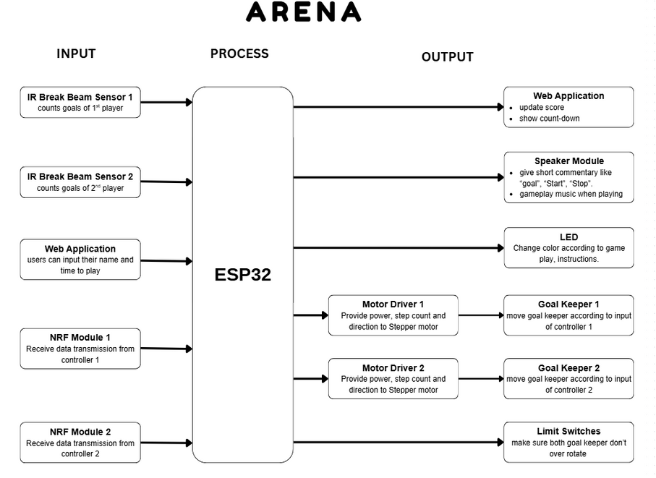

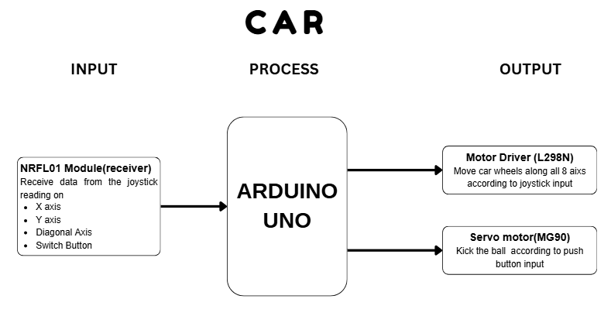

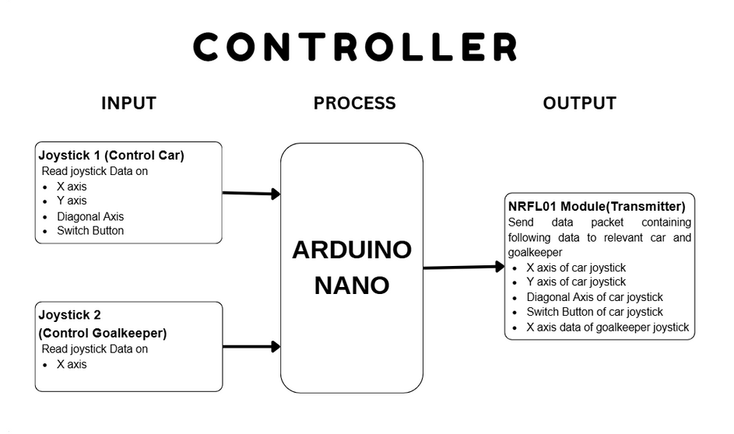

4.2 3D view of the output

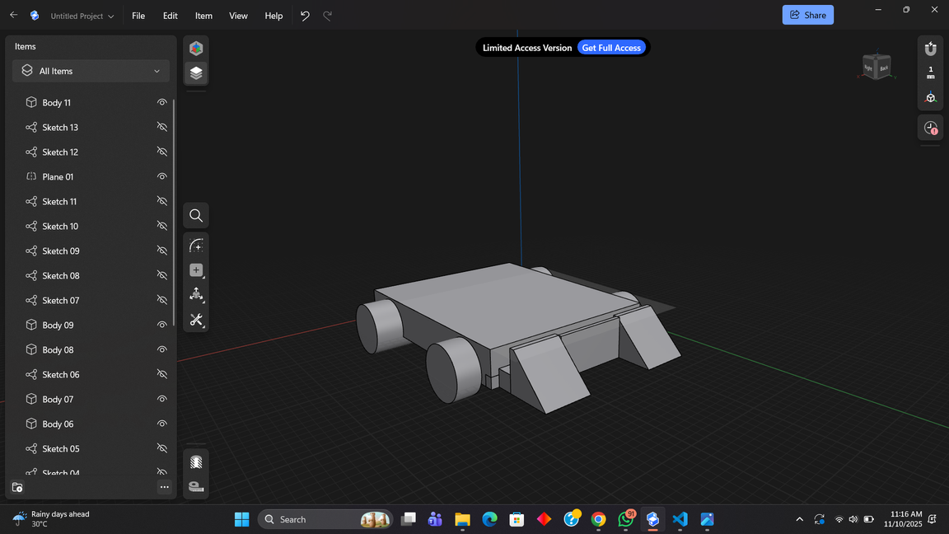

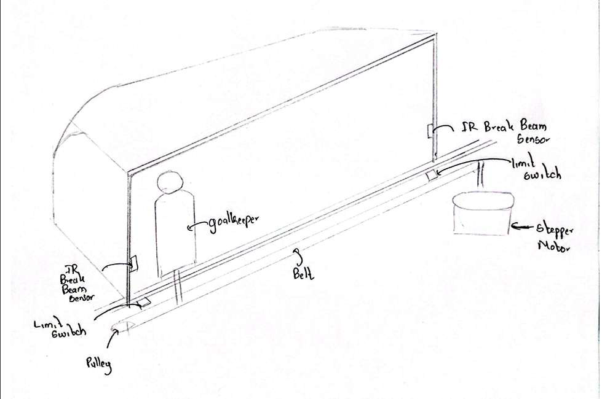
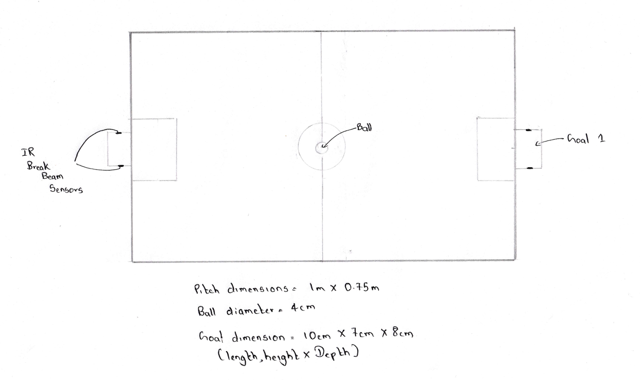
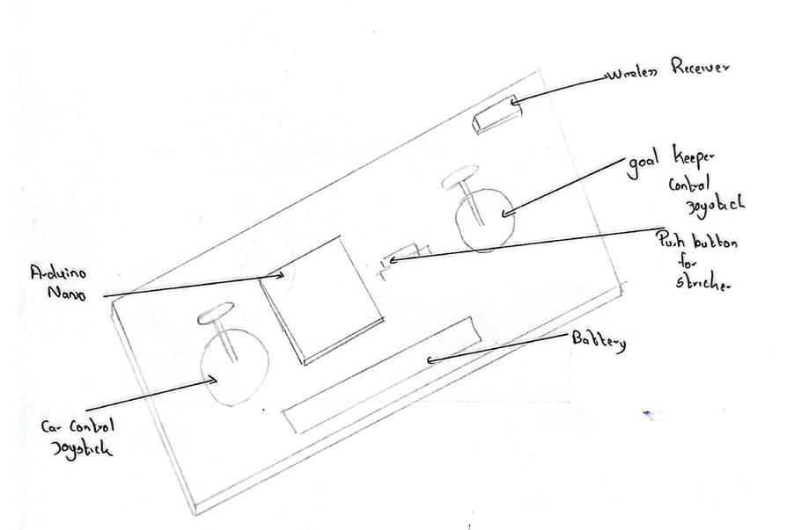

4.3 Circuit Diagram

- Kick Bot
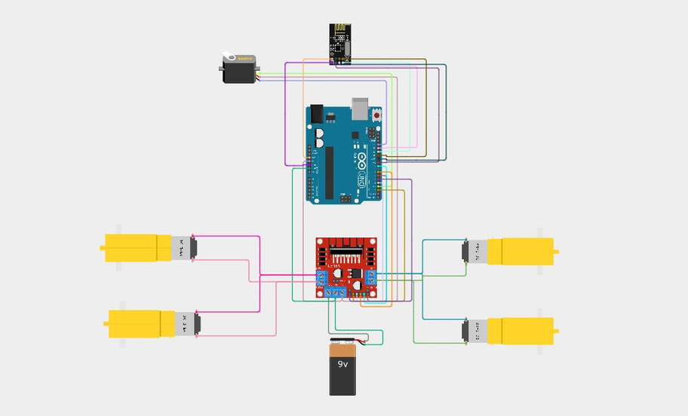

- Controller
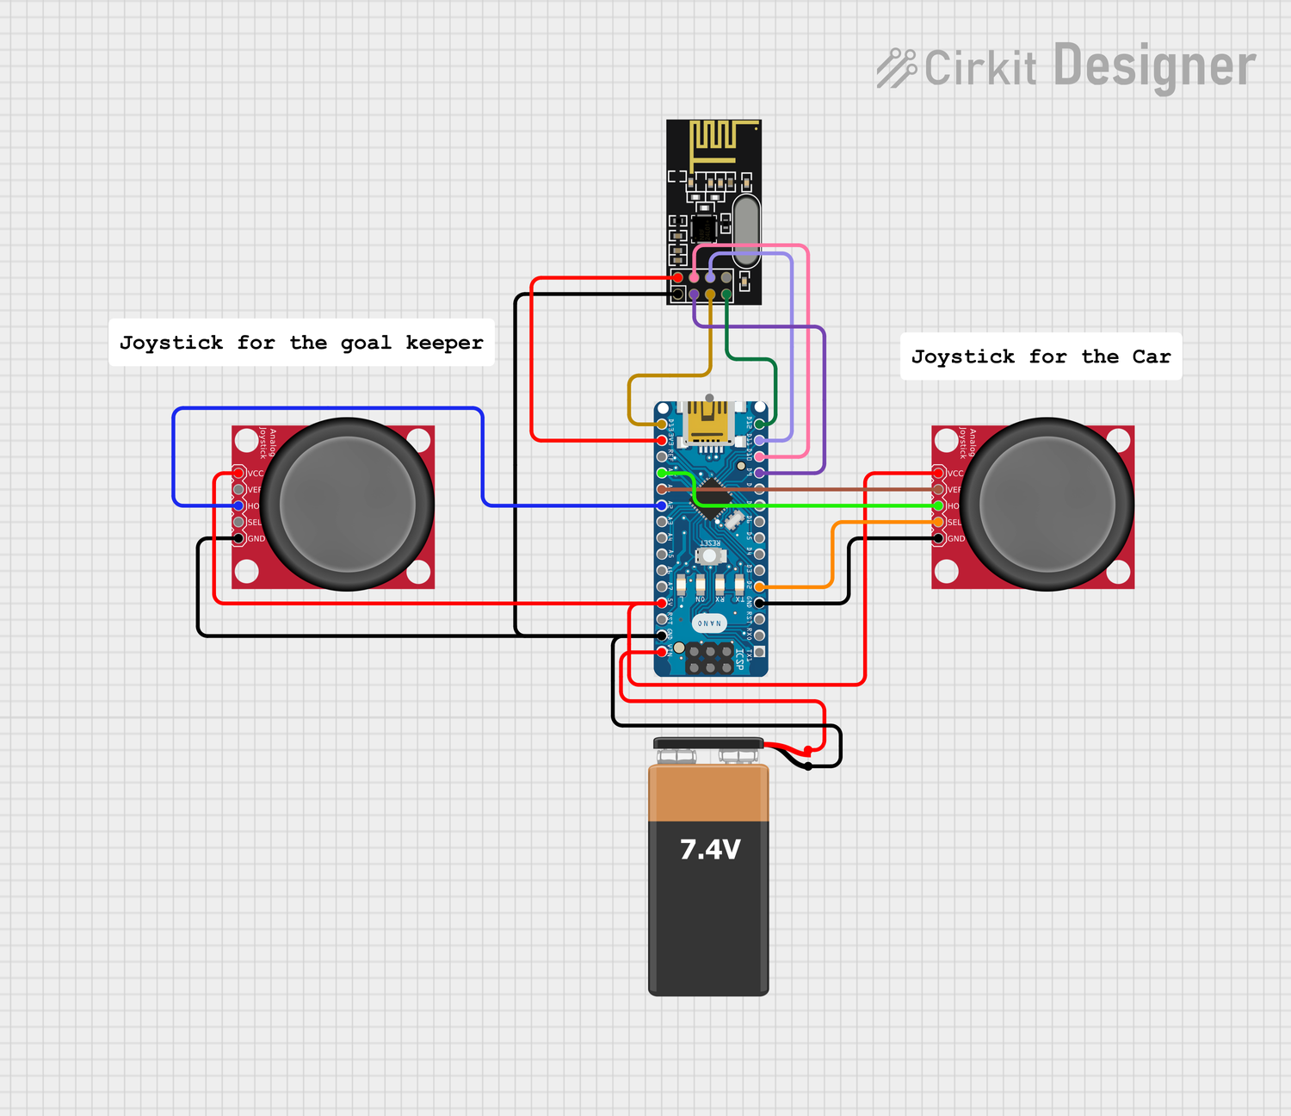

- Goal Keeper

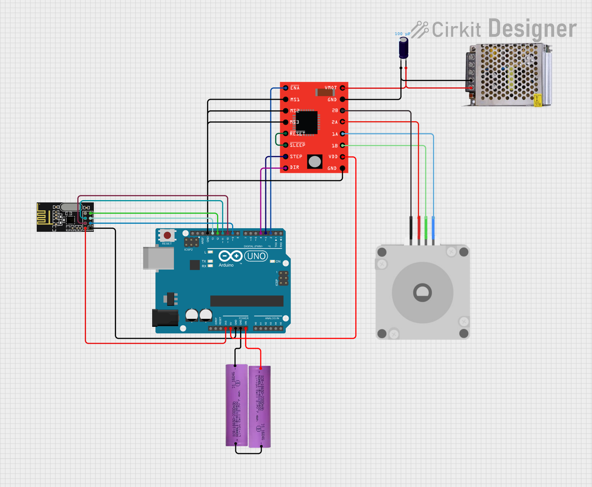

4.4 Project procedure

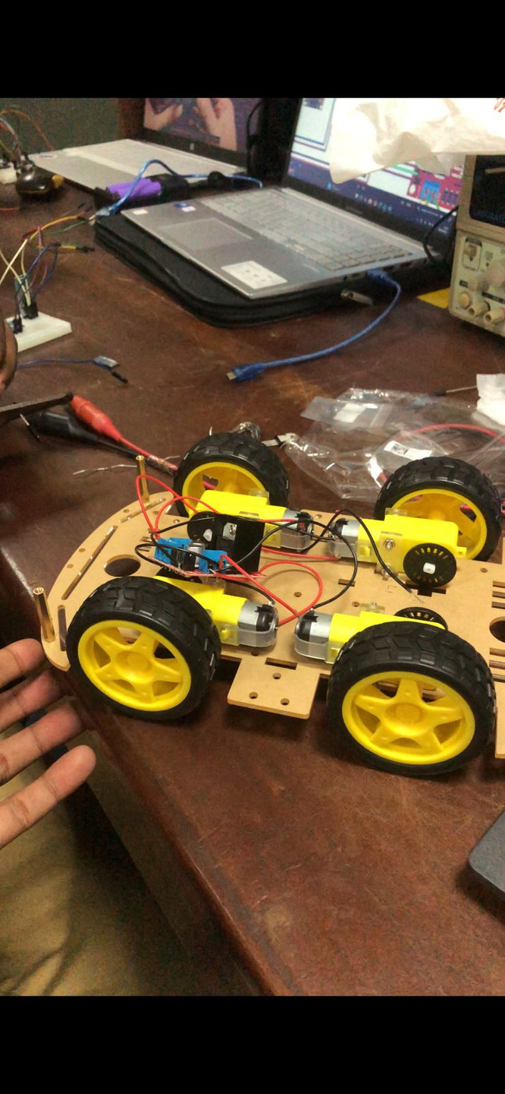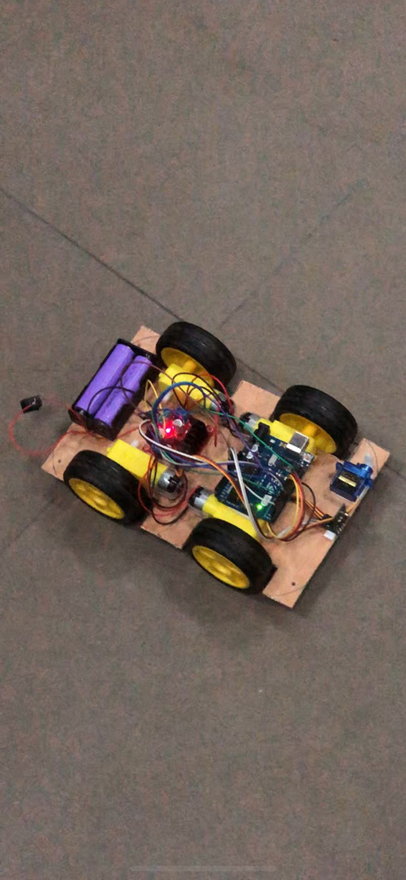

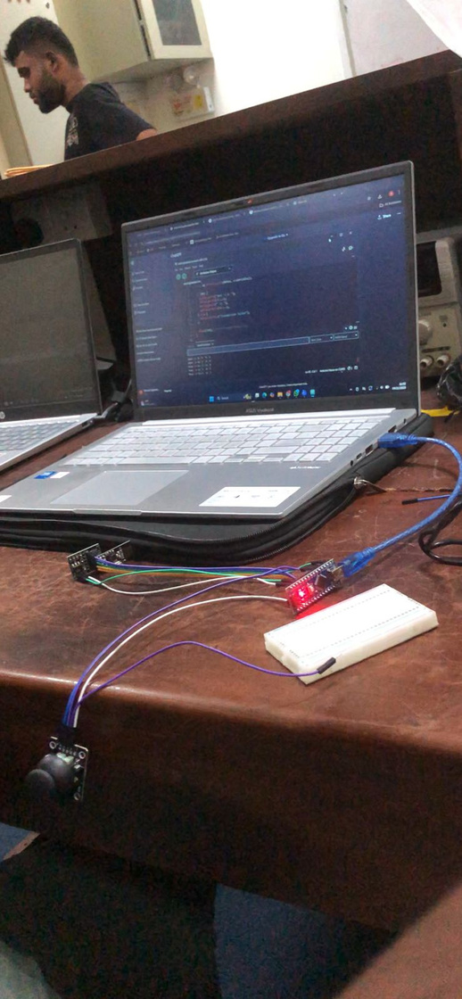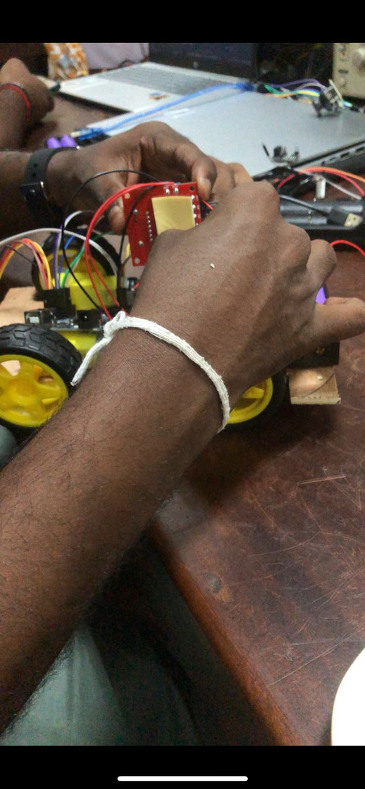

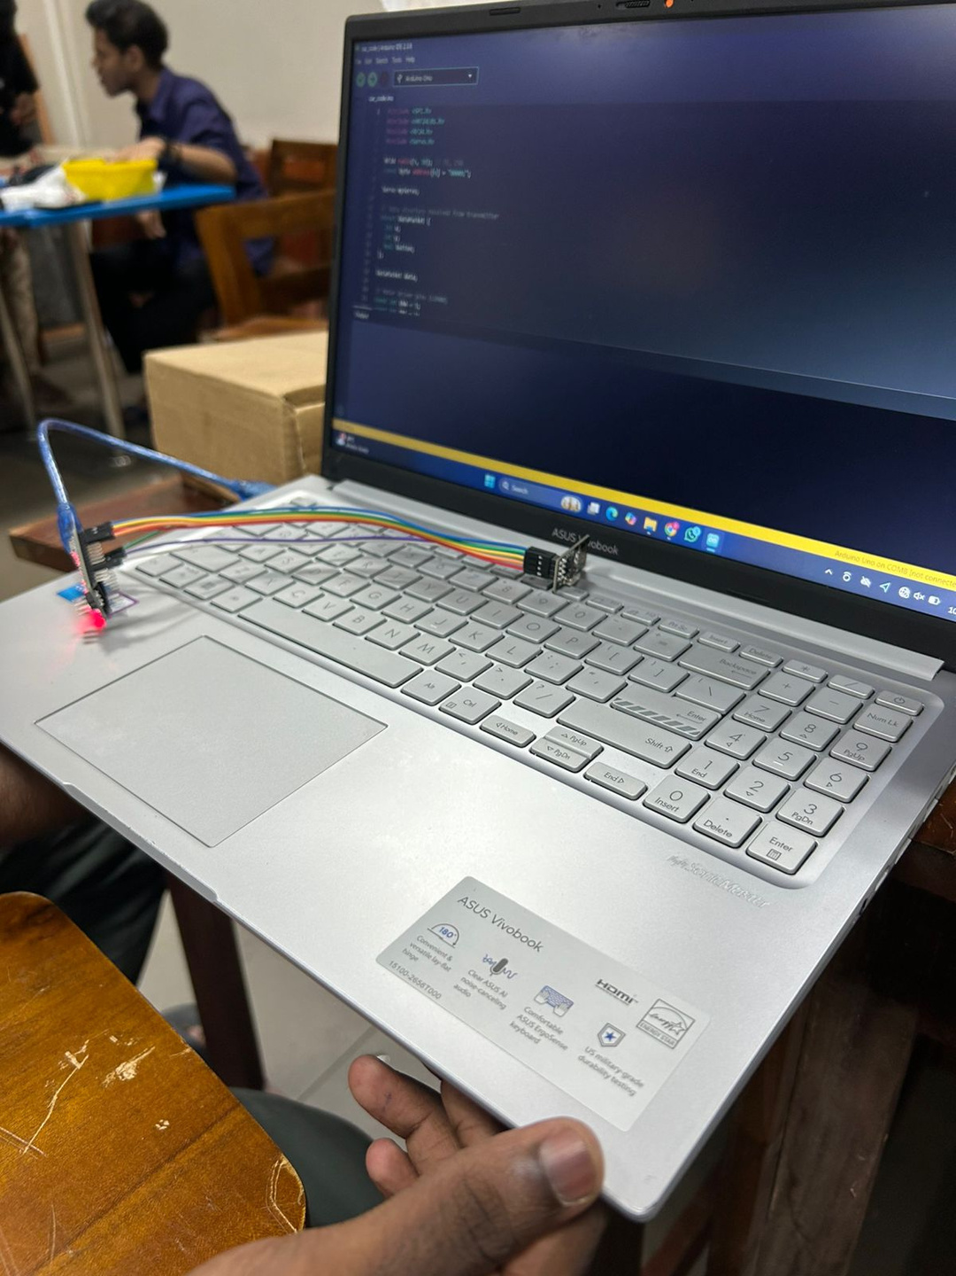

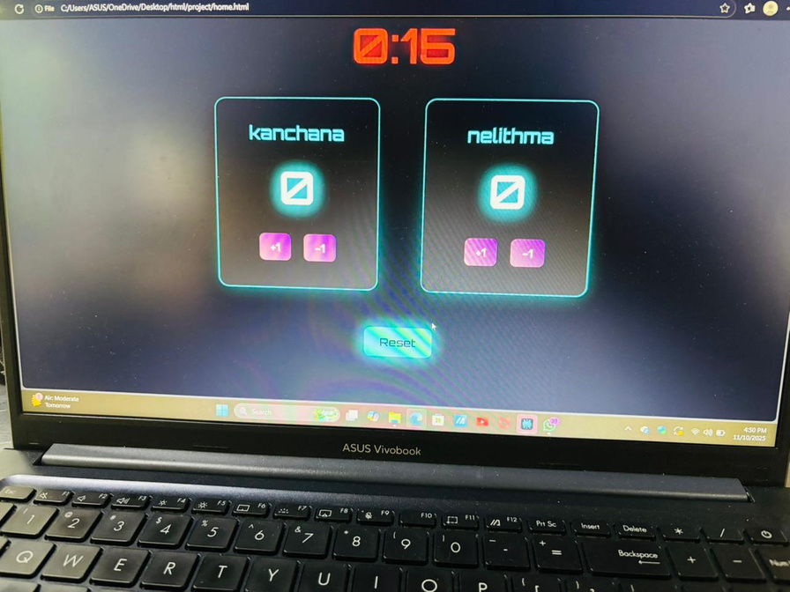

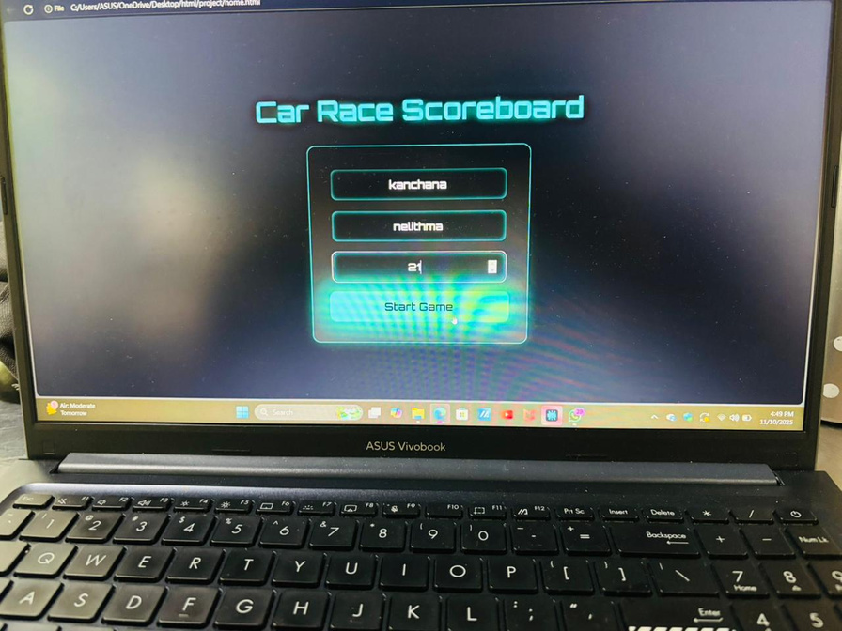

5. Components and used technologies

5.1 Joystick controller
Joysticks
The two joysticks are used to control the robot.
The left joystick moves the car forward, backward, left, and right.
The right joystick can be used for extra controls, like moving a servo or showing input on the arena.

Arduino Nano
The Arduino reads the joystick positions (as analog values) and converts them into digital data.
It then sends this data to the nRF24L01 module using SPI communication.

nRF24L01 Transmitter
This module sends the joystick data wirelessly to the receiver on the car and another on the arena.
This allows both to respond in real time without any wired connection.

Battery
The Li-ion battery powers the Arduino Nano and all connected parts, making the controller portable and easy to carry.

Overall Function
When the joysticks are moved, the Arduino reads the movement, sends the values wirelessly, and the car or arena reacts accordingly — for example, the car moves, or the arena display updates

5.2 Kick bot

nRF24L01 Receiver
This module receives the wireless data sent from the controller.
The received data contains joystick positions that decide the car’s movement.

Arduino Nano
The Arduino Nano on the car reads the data from the nRF24L01 module and decides which direction the motors should move.
It acts like the brain of the car.

Motor Driver (L298N)
The motor driver receives control signals from the Arduino and powers the DC motors accordingly.
It allows the car to move forward, backward, left, right, and diagonal axies depending on joystick input.

DC Motors
These motors are connected to the wheels and perform the actual movement of the car.
When the joystick is pushed forward, both motors move forward; when pushed back, both move backward; and for turns, only one motor runs.

Battery Pack
The Li-ion battery supplies power to the Arduino, motor driver, and motors.
It provides enough current for smooth movement.

Overall Function
When you move the joystick on the controller, the car instantly moves in that direction.
For example:
Joystick forward → Car moves forward
Joystick back → Car moves backward
Joystick left/right → Car turns left/right
Joystick Diagonal → Car moves along the Diagonal Path

5.3 Gaming arena

ESP32
The ESP32 controls the stepper motor and communicates wirelessly with the controller or through the web app.
It decides how and when the goalkeeper should move.

nRF24L01 Receiver
This module receives data from the controller, just like the car does.
The ESP32 reads this data to know the joystick movement.

Stepper Motor and Timing Belt
The stepper motor moves the goalkeeper left and right smoothly along the rail.
The motor turns in small steps, allowing accurate movement.

Web Application
The ESP32 connects to Wi-Fi and shows a web page that can display movement or allow manual control from a phone or laptop.

Power Supply
Power Adaptor gives power to the ESP32 and the stepper motors.

5.4 Software components

1. Arduino IDE
Used to write, upload, and debug the code for the ESP32 and Arduino Nano boards.
The programming is done in C/C++ language using Arduino libraries.
It includes the code for:
Reading joystick and sensor data
Sending and receiving data through the nRF24L01 module
Controlling the stepper motor for the goalkeeper
Handling serial communication

2. ESP32 Web Server
The ESP32 acts as a local web server that hosts the web application.
The web page is created using HTML, CSS, and JavaScript, stored in the ESP32’s memory.
When a phone or laptop connects to the ESP32’s Wi-Fi, it can open the web page to:
Control the goalkeeper manually
View the joystick or movement data live

3. HTML / CSS / JavaScript (Web App)
These are used to design and run the web interface:
HTML – Structure of the web page (buttons, text, sliders)
CSS – Styling and layout for a clean design
JavaScript – Adds interaction (sending commands to ESP32 using HTTP requests)
The interface is simple and user-friendly so anyone can control the arena easily.

4. Libraries Used
WiFi.h – For connecting ESP32 to Wi-Fi.
WebServer.h or ESPAsyncWebServer.h – For hosting the web app.
AccelStepper.h – For controlling the stepper motor movement smoothly.
SPI.h and RF24.h – For communication between ESP32 and nRF24L01 module.
Arduino.h – For general Arduino functions and timing.

5. Overall Software Function
The controller sends joystick data wirelessly.
The ESP32 receives that data through nRF24L01 or Wi-Fi.
Based on the data, the stepper motor moves the goalkeeper.
The web application displays or allows manual control of the movement.

6. Work Distribution
Team member | Role | Responsibility
245031B | Cars design and Game Logic | Arduino Uno Setup for Both cars, Design Chassis, Data Communication through NRF24L01 modules, Initiate Car movements along all directions, implementing the kickers for the cars. Implementing game logics
245056F | Controllers Design and Coding | Arduino Nano setup for Both controllers, Controller setup Design, Data transmission to both car and Arena through NRF24L01 module, Implementing real time update of web application.
245060L | Other arena functions and Coding | Power supply for arena , car and controllers, Implementing other arena outputs (LED, Speaker Module)that change according to game play. App Development: Building App structure and UI.
245057J | PCB design and Goal counting mechanism | Controller PCB Design. Implementing goal counting mechanism for both ends .Connecting ESP32 of arena with web application(ESPNOW). Overall system testing, debugging and error correction.
245124M | Structure and Goal Keeper mechanism | Creating and design the arena to house all components along with both goal keeper mechanism, design Goal keeper movement (by NEMA 17 motors and rails/belts). Implementing limit switches for goal keepers.

7. References

https://youtu.be/Z7_Cy66Vnrc?si=KXOrc6KhChikbLDL
https://youtu.be/JSHJ-RLbNJk?si=hRrSfhF58SNRVxCc
https://forum.arduino.cc/t/nrf24l01-ping-pong-issue/559350
https://github.com/aslam-Hossain-YT/Joystick-Control-Bluetooth-Car
https://youtu.be/ENRFh83hHM8?si=avthUNHjc7eUXwmE

